**BUG REPORT OF TEA DIARY APPLICATION**

**Name:** Warish Kumar

**Device:** Vivo y75 5G

**Android Version:** 12

**APK Version:** 1.2

**Bug Id: 1**

**Module Name:** Seller

**Bug Description:** When add seller & navigate back from Manage Item it’s redirect on Dashboard.

**Steps:** 1) Click on Seller 2) Click on any seller name 3) Click on back from mobile navigation button

**Expected Result:** It should redirect in Item List.

**Bug Images:**

**Bug Id: 2**

**Module Name:** Seller

**Bug Description:** It’s allow same name for multiple time with help of different Upper case and lower case

**Steps:** 1) Click on Seller 2) Click on Add button 3) Enter same with multiple times with different combination of upper case and lower case

**Test Data:** Name : WARISH, Name : warish, Name: Warish, Name: Warish, Name: waRisH, Name: WaRiSh (*It’s accept same Mobile number for all the mentioned Name)

**Expected Result:** It should not allow same name for multiple time

**Bug Images:**

**Bug Id: 3**

**Module Name: Seller**

**Bug Description:** When enter space in name field without any character it’s allow.

**Steps:** 1) Click on Seller 2) Click on Add Button 3) Enter space in Name field and valid mobile number and click on Save.

**Test Data: Name = “ “**

**Expected Result:** It should not allow name with space only.

**Bug Images:**

**Bug Id: 4**

**Module Name:** Seller

**Bug Description:** When enter zero in Mobile field, then it’s only show one zero in Mobile of seller list.

**Steps:** 1) Click on Seller 2) Click on any button 3) Enter valid name and enter zero in Mobile

**Test Data:** Name: Warish, Mobile: 000000000

**Expected Result:** It should show all zeros in contact number.

**Bug Images:**

**Bug Id: 5**

**Module Name:** Seller

**Bug Description:** When enter junk character, special character or other language, it directly crashed application.

**Steps:** 1) Click on Seller 2) Click on add button 3) Enter junk character, special character or other language in Name field. 4) Enter 10 digit in mobile number and click on save button

**Expected Result:** It should not crashed application.

**Bug Images:**

**Bug Id: 6**

**Module Name:** Item

**Bug Description:** When add any item, Name and Price field only allow 10 character and 3 digit respective.

**Steps:** 1) Click on Item 2) Click on add button 3) Enter more than 10 characters in Name & try to enter 1000 in Price.

**Test Data:** Name: Black Coffee, Price: 9999

**Expected Result:** It should allow more than 10 characters in Name and more than 3 digits in Price.

**Bug Images:**

**Bug Id: 7**

**Module Name:** Item

**Bug Description:** It’s allow same name for multiple time with help of different Upper case and lower case

**Steps:** 1) Click on Item 2) Click on Add button 3) Enter same with multiple times with different combination of upper case and lower case

**Test Data:** Name : Paneer, Name : PANEER, Name: paneer, Name: pAnEeR, Name: PAneeR, Name: PaNeEr (*It’s allow all above item with same price also)

**Expected Result:** It should not allow same name for multiple time

**Bug Images:**

**Bug Id: 8**

**Module Name:** Seller**,** Item

**Bug Description:** Trimming is not working in Name of seller or item.

**Steps:** 1) Click on Seller/item 2) Click on Add button 3) Enter space & then name.

**Test Data:** Name: Warish, Name: Tea

**Expected Result:** It should trim the blank space before name.

**Bug Images:**

**For Item List**

**For Seller List**

**Bug Id: 9**

**Module Name:** Seller**,** Item

**Bug Description:** Allow when enter only special character, Emoji, or blank space in Name field.

**Steps:** 1) Click on Seller/item 2) Click on Add button 3) Enter special character in Name field.

**Test Data:** Name: ####, Name: &&&

**Expected Result:** It should not allow name with only special characters, emoji, or blank space.

**Bug Images:**

**Bug Id: 10**

**Module Name:** Seller

**Bug Description:** No message is shown when not data in seller.

**Steps:** 1) Click on Seller

**Test Data:**

**Expected Result:** It should show message as “No Data Found” or should have option to add seller on page.

**Suggestion:** No page of application should blank.

**Bug Images:**

**Bug Id: 11**

**Module Name:** Sellerwise Item

**Bug Description:** When no item is selected for seller, click on save it’s redirect to New Order page.

**Steps:** 1) Click on Sellerwise item 2) Unchecked all item and click on save

**Test Data:**

**Expected Result:** It should not redirect to Order page when no item is selected.

**Suggestion:**

**Bug Images:**

**Bug Id: 12**

**Module Name:** Sellerwise Item

**Bug Description:** When checked any item and change the prize. But when we unchecked the same item, it’s remain same as previous price.

**Steps:** 1) Click on Sellerwise item 2) Click on any item. 3) Change the prize and click on OK 4) Unchecked the same item

**Test Data:**

**Expected Result:** Updated price of item should not change after unchecked.

**Suggestion:**

**Bug Images:**

**Bug Id: 13**

**Module Name:** Sellerwise Item

**Bug Description:** When select any item to buy and click on Save. Then in New Order page select quantity of 1 item and click on place. Then in dashboard & Order Details it’s not same in quantity and price as order placed.

**Steps:**

1) Click on Sellerwise item

2) Click on any item.

3) Enter amount and click on Ok, then click on Save button

4) In New Order page quantity of item is increased by one & Click on Place Order.

5) Now click on “Tea/Coffee” for order details and click on Show button and see the price of item for seller.

6) Then click on seller name and see the Order Detail.

**Test Data:**

**Expected Result:** Order details should be same at every place.

**Suggestion:**

**Bug Images:**

**Bug Id: 14**

**Module Name:** Seller

**Bug Description:** By updating process we can keep the same seller’s name for multiple times.

**Steps:** 1) Click on Seller 2) Click on any seller. 3) Update the name with existing seller name

**Test Data:**

**Expected Result:** Updated price of item should not change after unchecked.

**Suggestion:**

**Bug Images:**

**Bug Id: 15**

**Module Name:** Seller

**Bug Description:** Invalid mobile number is accepted by application.

**Steps:** 1) Click on Seller 2) Click on add seller. 3) Enter name and Mobile number having zero before any digit.

**Test Data:** Name: Seller 1, Mobile = 00000007890

**Expected Result:** It should not allow invalid mobile number.

**Suggestion:**

**Bug Images:**

**Bug Id: 16**

**Module Name:** Seller

**Bug Description:** When delete any seller the title of pop window for delete is not correct.

**Steps:** 1) Click on Seller 2) Select any seller. 3) Click on delete button.

**Test Data:**

**Expected Result:** System should prompt proper title for delete confirmation instead of Add Order.

**Suggestion:**

**Bug Images:**

**Bug Id: 17**

**Module Name:** Seller

**Bug Description:** When keep empty name field click on save button with valid number, cursor doesn’t move to name field.

**Steps:** 1) Click on Seller 2) Click on add seller. 3) Keep name field empty & enter mobile.

**Test Data:** Name: “ “, Mobile = 1234567890

**Expected Result:** Cursor should move to name field when save with empty name.

**Suggestion:**

**Bug Images:**

**Bug Id: 1**8

**Module Name:** New Order

**Bug Description:** When select any seller having no item assigned to him & again try to select another seller at that time it’s doesn’t update item list respectively.

**Steps:** 1) Click on New Order 2) Select any seller having no item. 3) Again, try to switch another seller which have item.

**Expected Result:** System should show item list according to Sellerwise at every time when it’s switch to another seller.

**Suggestion:**

**Bug Images:**

**Bug Id: 19**

**Module Name:** Item

**Bug Description:** When click on Price filed of item details of any item, it’s automatically deleted all text from that field.

**Steps:** 1) Click Item 2) Select any item for update. 3) Click on price filed.

**Expected Result:** System should allow user to edit with previous existing data of price field.

**Suggestion:**

**Bug Images:**

**Bug Id: 20**

**Module Name:** Item

**Bug Description:** System have not option to delete any item from item list.

**Steps:** 1) Click Item 2) Select any item

**Expected Result:** System should have option to remove particular item from item list.

**Suggestion:**

**Bug Images:**

**Bug Id: 21**

**Module Name: Sellerwise item**

**Bug Description:** When add any item to seller (Seller name with special/junk character).

**Steps:** 1) Click on sellerwise item 2) Click on add New Item with selecting seller have special/junk character in name.

**Expected Result:** Application should not crashed when add any seller’s item.

**Suggestion:**

**Bug Images:**

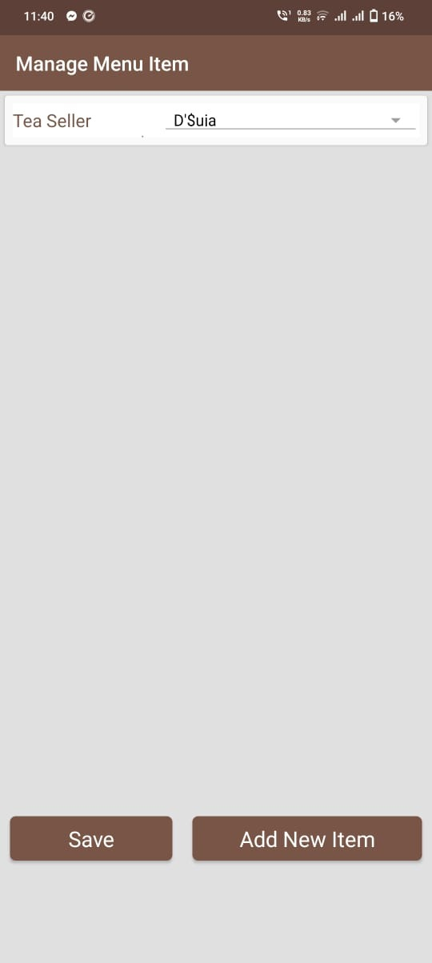 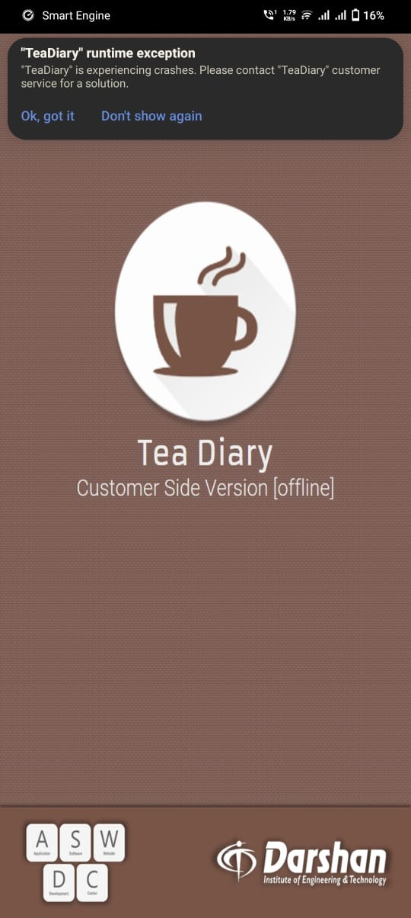

**Bug Id: 22**

**Module Name: New Order**

**Bug Description:** When order placed in previous day from calendar, system allow to placed order.

**Steps:** 1) Click New Order 2) Select quantity for any seller 3) click on calendar and select any previous date or year 4) Click on Place Order.

**Expected Result:** System should not allow to order placed in previous date or year.

**Suggestion:**

**Bug Images:**

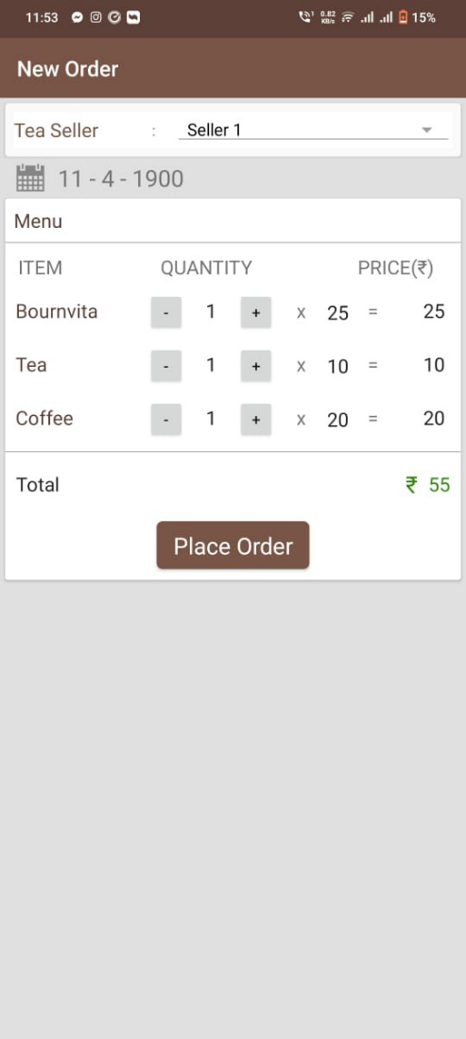 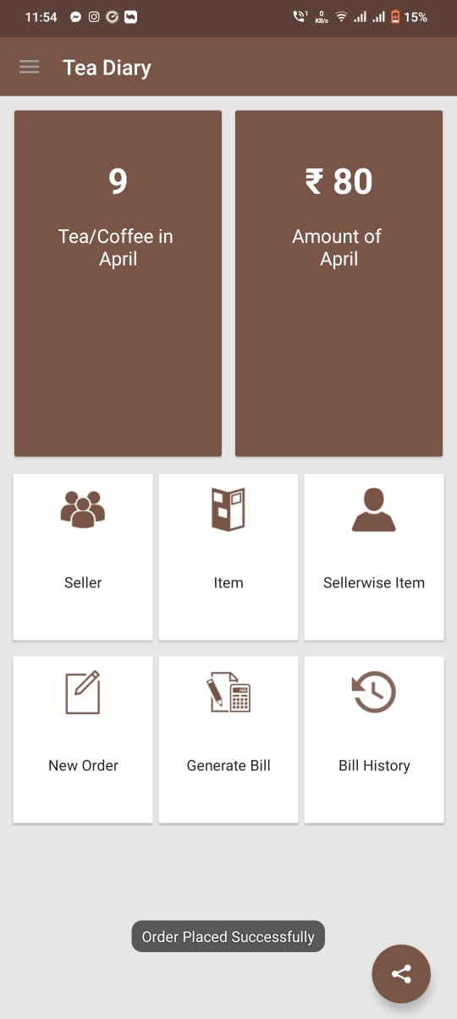

**Bug Id: 23**

**Module Name:** Re installationofApplication

**Bug Description:** When uninstall the application and again install it, it stores previous data.

**Steps:** 1) Uninstall the application 2) Again install Application and open it.

**Expected Result:** System should not store cache store when application uninstall and reinstall the application.

**Suggestion:** Previous data should only recover when login module exist in the module.

**Bug Images:**

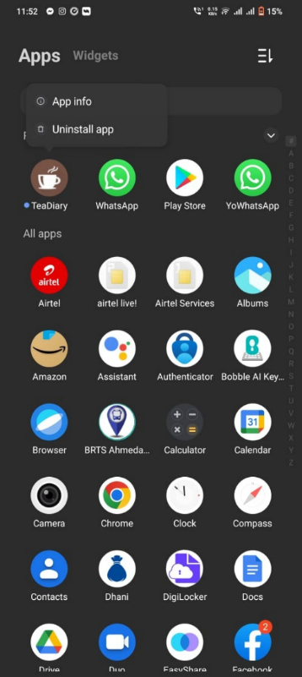 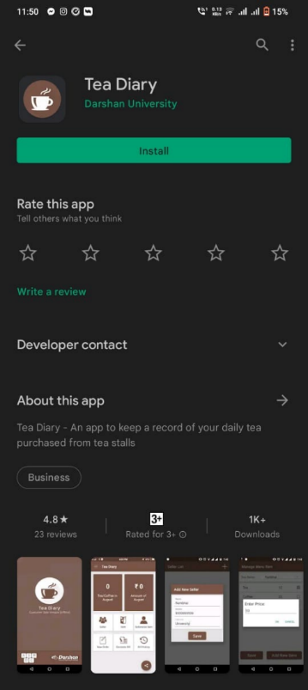 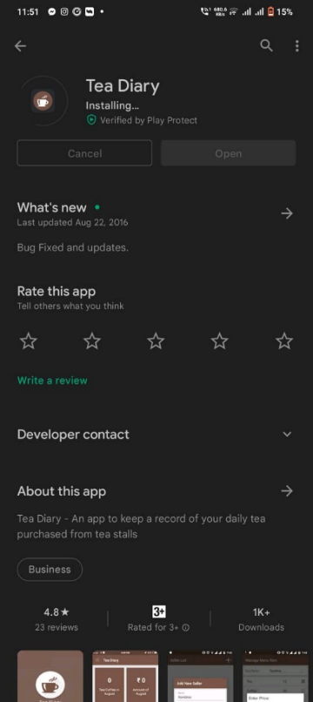 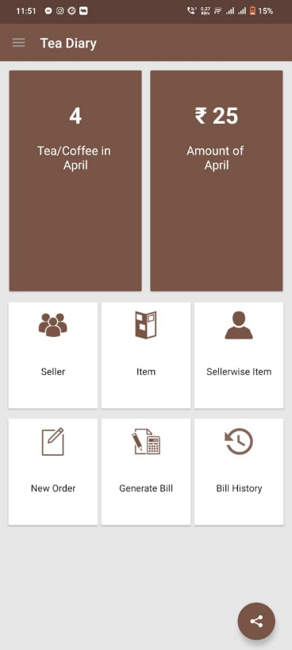

**Bug Id: 24**

**Module Name:** Billing

**Bug Description:** When user enters “From” date greater than “To” date, system allow to select.

**Steps:** 1)

**Expected Result:** Date can’t be selected more than today.

**Suggestion:** Calendar shouldn’t allow to move next date, month, or year after current date.

**Bug Images:**

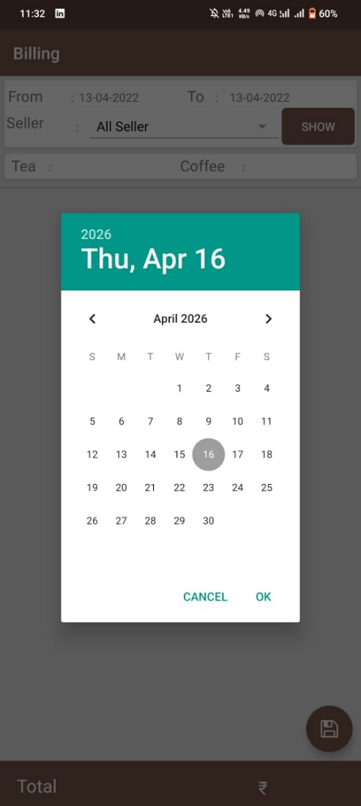

**Bug Id: 25**

**Module Name:** New Order

**Bug Description:** When user manually changes the quantity to the max value 999 and click on plus button quantity gets changed to 100.

**Steps:** 1) Click on New Order 2) Change the quantity by type manually 999 3) Press on + button

**Expected Result:** After press on + icon, it should not be go on 100.

**Suggestion:** If according to requirement it not allow to enter more than 999, then it should not allow to add after 999 (+ key should be disable after 999) otherwise it should increase by 1000.

**Bug Images:**

**\*\*\* When select seller name having junk character in New Order, It’s directly crash the application.**